Assignment 01 Outputs

Task 01:

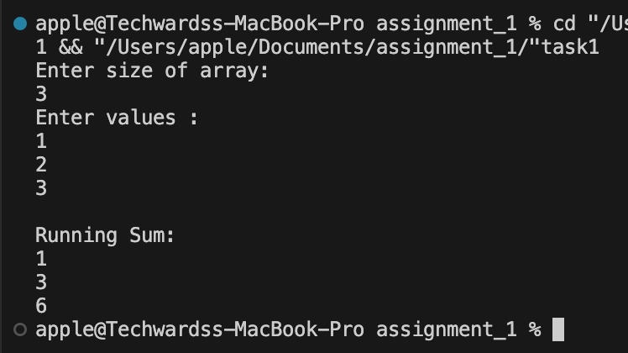

Task 02:

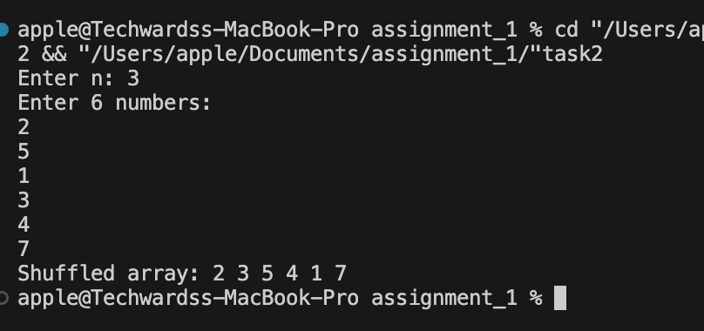

Task 03:

